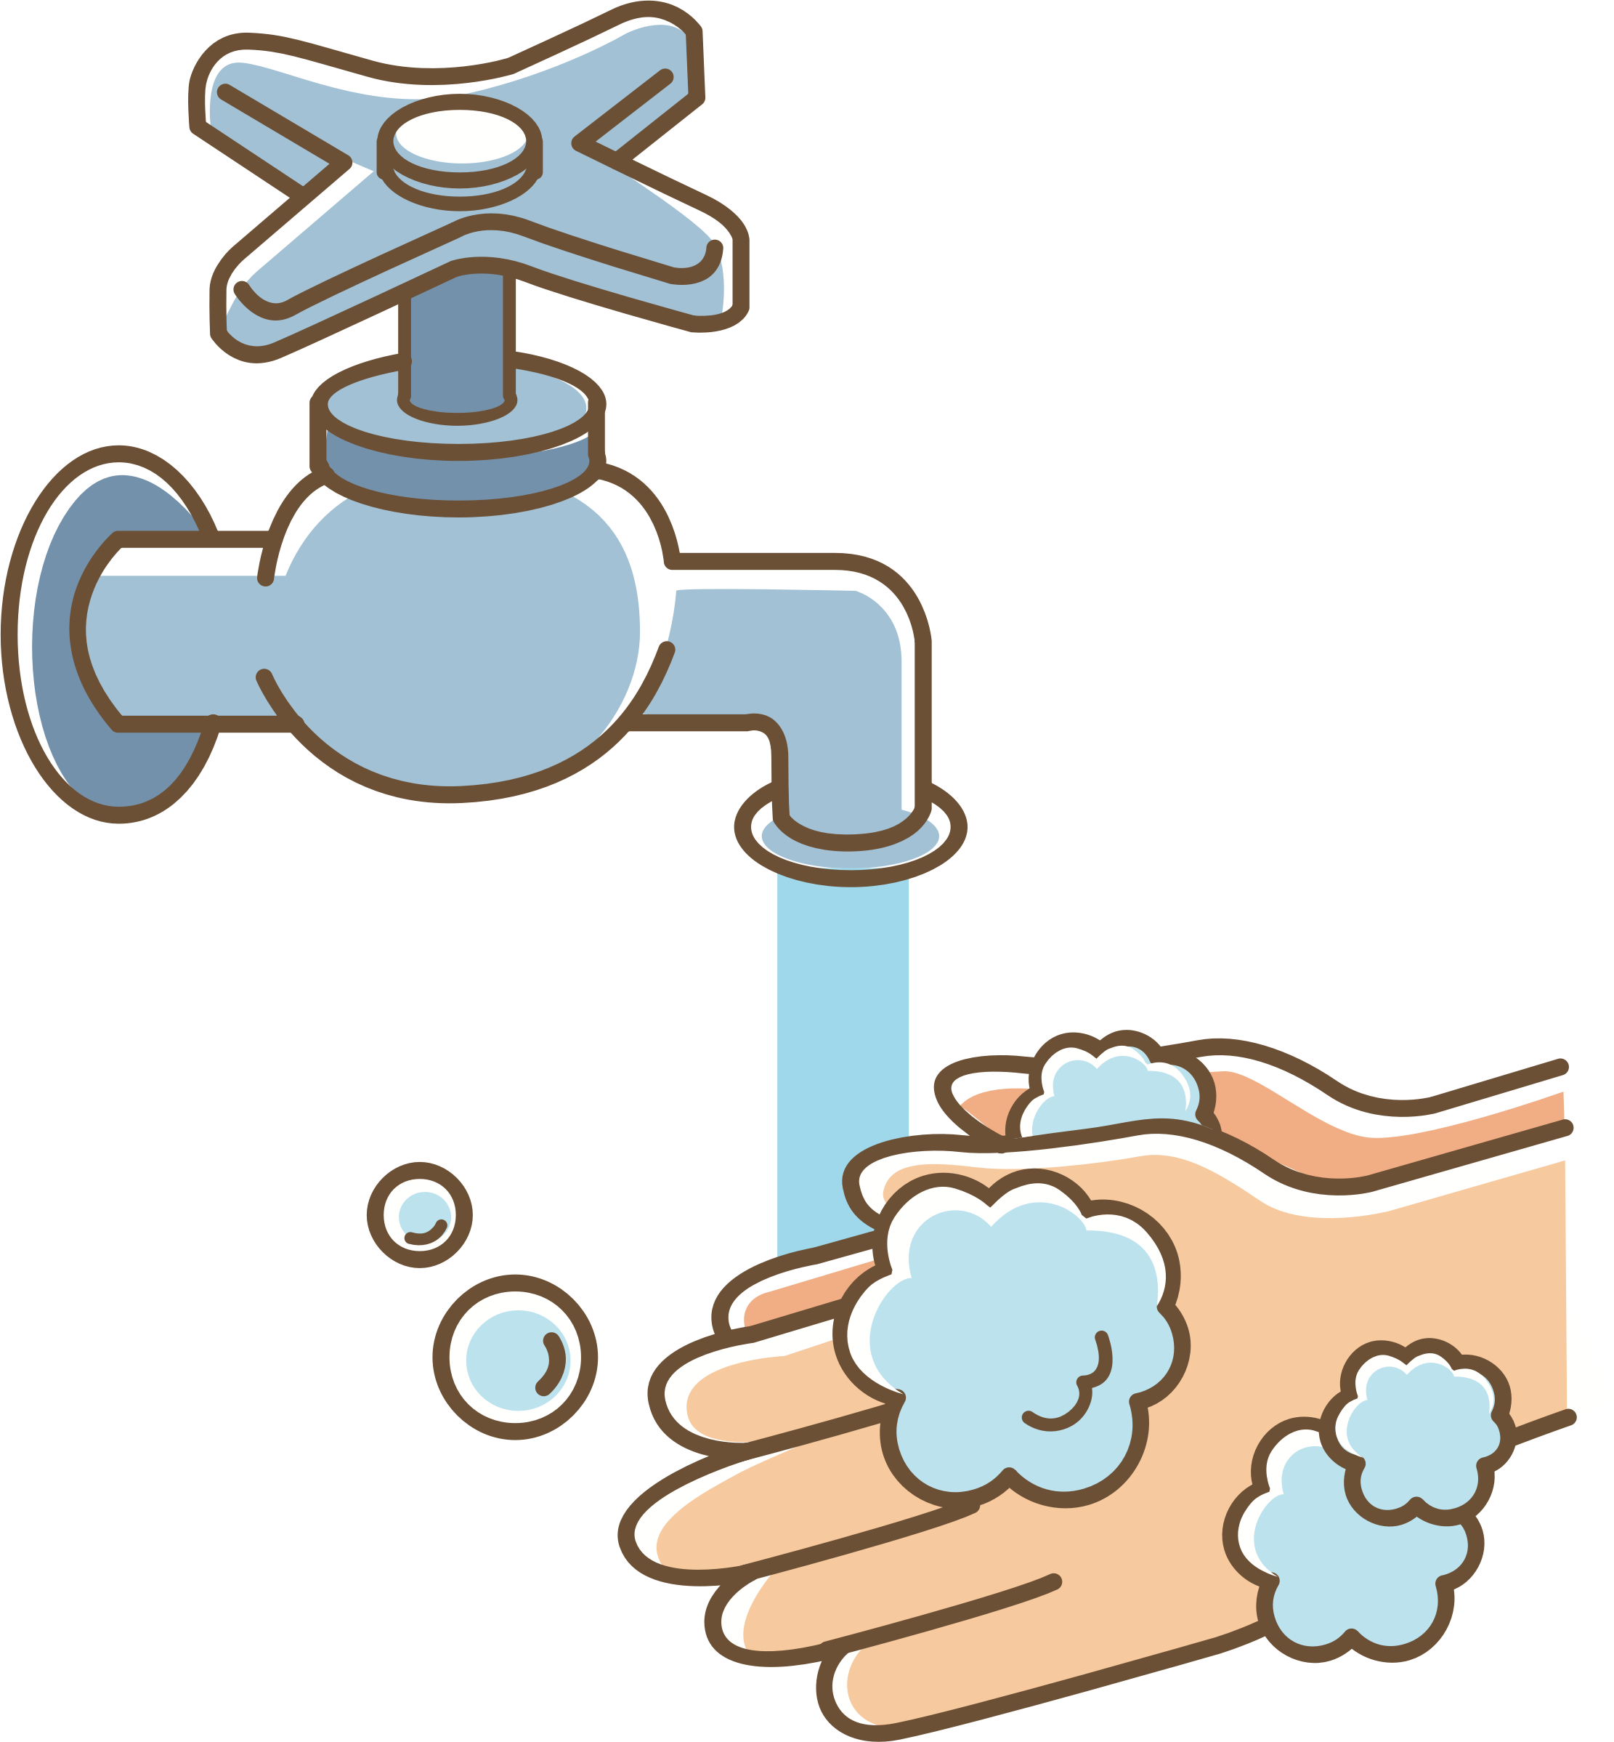



Wash your hands to the tune of ‘Baby Shark by PinkFong’

Wash your Hands doo doo, doo doo doo doo  
Wash your Hands doo doo, doo doo doo doo  
Wash your Hands doo doo, doo doo doo doo  
Wash your Hands

Use some Soap doo doo, doo doo doo doo  
Use some Soap doo doo, doo doo doo doo  
Use some Soap doo doo, doo doo doo doo  
Use some Soap

Back & Front doo doo, doo doo doo doo  
Fingers too doo doo, doo doo doo doo  
Back and Front doo doo, doo doo doo doo  
Fingers too

Time to rinse doo doo, doo doo doo doo  
Time to Rinse doo doo, doo doo doo doo  
Time to Rinse doo doo, doo doo doo doo  
Time to Rinse



